# **WeBWorK-Blackboard Integration**

### **Faculty login and content linking**

**Instructors’ login**

Instructors, TAs and professors access and manage their WeBWorK courses in the usual way as before the WeBWorK-Blackboard integration. That means that they use the WeBWorK front page <http://webwork.qcc.cuny.edu/webwork2>.

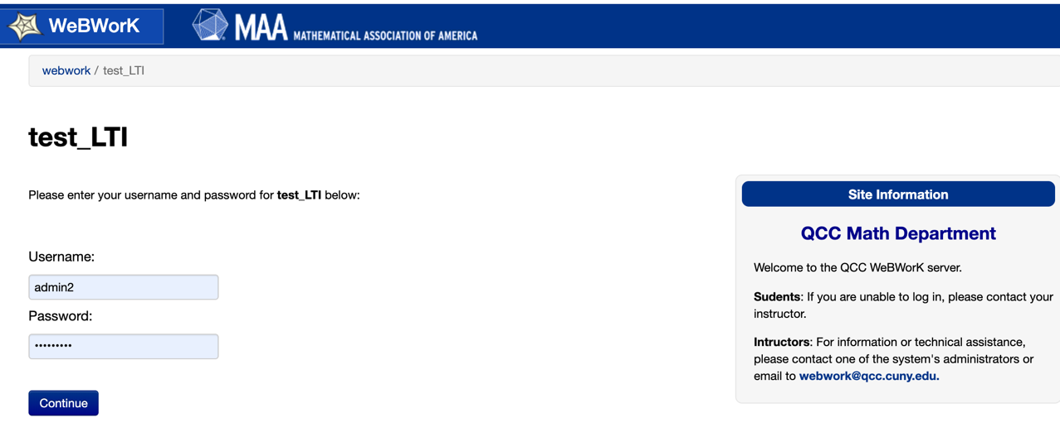

In the LTI’s default configuration of WeBWorK, accounts for users with roles of TA or higher are NOT created via Blackboard. That means that the accounts for the instructors are created manually in WeBWorK by the system’s administrators as it has been done since the system was implemented at QCC.

Instructors, professors and TAs cannot access WeBWorK via Blackboard. If a user in one of these roles attempts to login into WeBWorK via Blackboard, the following error message appears.

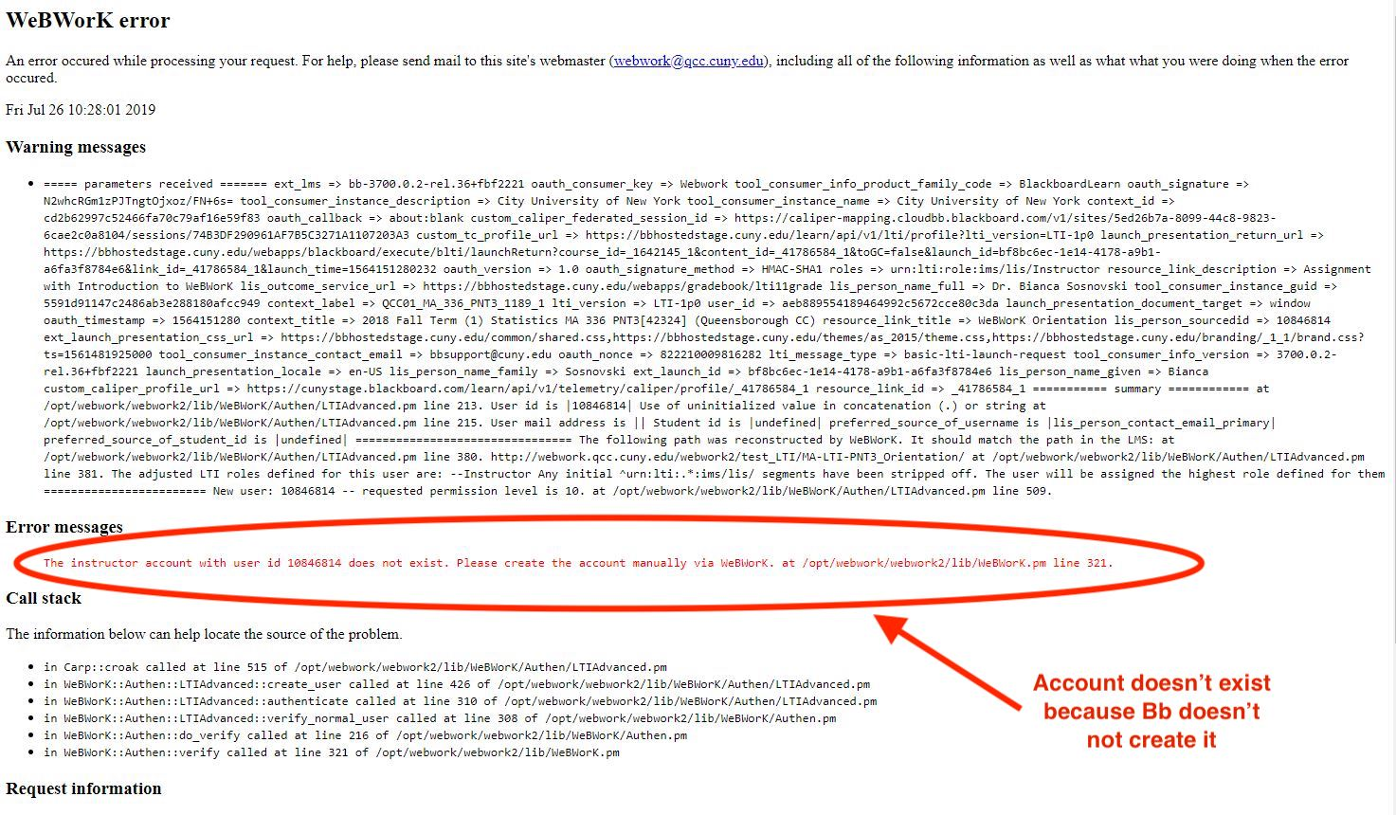

If an instructor uses the “Student Preview” mode in Blackboard, then a student account can be created in WeBWorK and they will be allowed to login to WeBWorK via Blackboard as any student would.

For security reasons, the cut off at the TA level for creation of LTI based accounts is to prevent instructors with LMS access to point to an existing WeBWorK URL to any other course. Thus, able to add themselves (and potentially their students) to somebody else’s course. With the default cut off to TA, the worst case is that an unauthorized student webwork account gets created for the course by a faculty using “Student Preview”.

**Content linking in Blackboard**

1. **Enable LTI in Blackboard**

In the Blackboard menu under “Customization” click on “Tool Availability”. Scroll down and make sure the box in the **QCC WeBWorK** row (in the “Available” column) is checked.

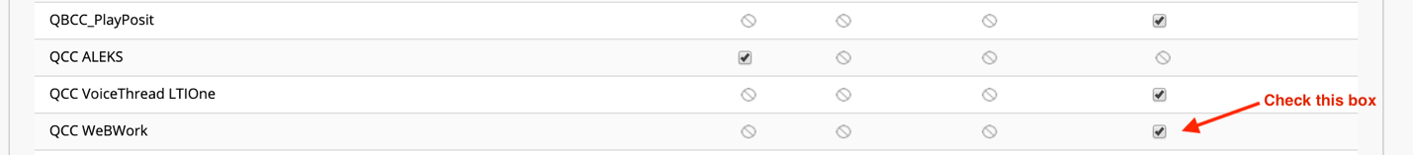

1. **Create an assignment**

Instructors create assignments in WeBWorK as usual. For more information about this, check <https://github.com/bsosnovski/WW-Converter>

The necessary steps in creating an assignment in WeBWorK are:

* Name the new assignment (e.g. MA-LTI-PNT3_Orientation).
* Select the questions/problems to be part of the assignment.
* Set dates for when the assignment opens, closes and when the answers will be available.
* Make the assignment visible.

The last two steps are shown below.

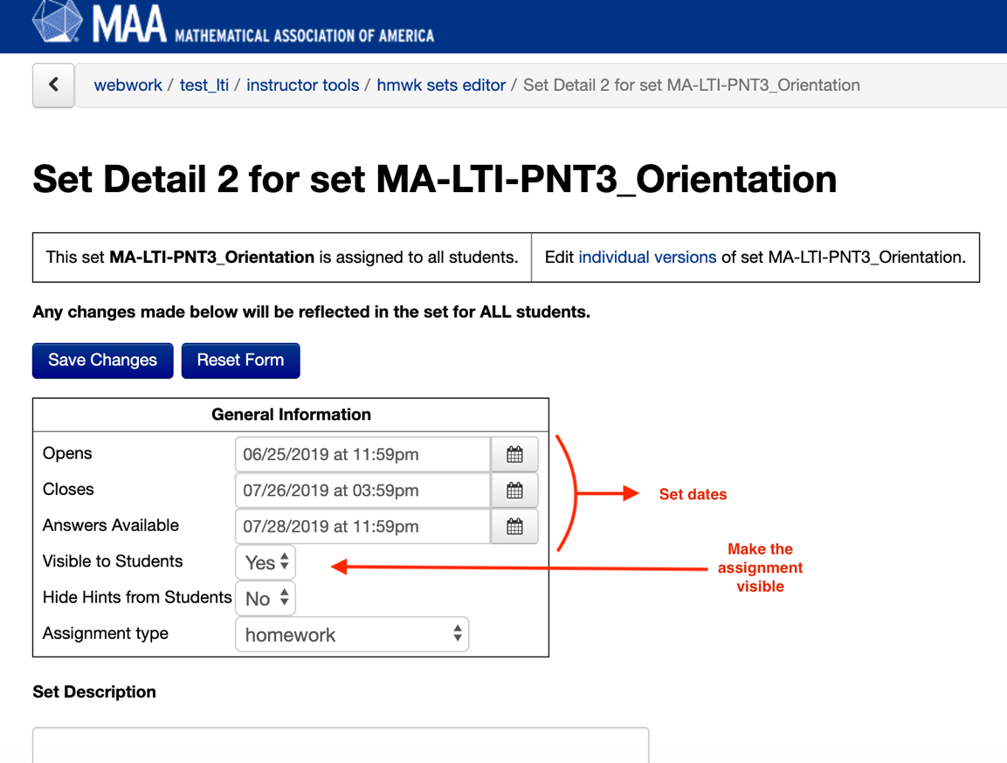

1. **Linking the assignment in Blackboard**

Once the WeBWorK assignment is ready, the instructor will need to make a link/assignment in Blackboard that students can use to get to WeBWorK.

* Go to the content area where you want the assignment link to appear.
* Go Build Content > Web Link.
* Add a name for the assignment.
* Add the URL of the assignment you are linking to. (the URL looks like: **http://webwork.qcc.cuny.edu/webwork2/CourseName/Assignment**)
* Check the box "This link is a Tool Provider".
* Enable Evaluation and make visible to students.
* Set the number of points (same as in WeBWorK)
* (Optional) Set the due date in Blackboard.
* (Recommended) Set the link to open the assignment in a new window.

**Example:**

A valid link for linking an assignment is like

<http://webwork.qcc.cuny.edu/webwork2/test_LTI/MA-LTI-PNT3_Orientation>

**Note:**

Visibility and due dates of assignments are not automatically synchronized. Changing theses in WeBWorK doesn’t change them automatically in Blackboard. Though instructors have to set these features in both systems separately, it is recommended that instructors to set due dates also in Blackboard and to allow WeBWorK to control the availability of the assignments.

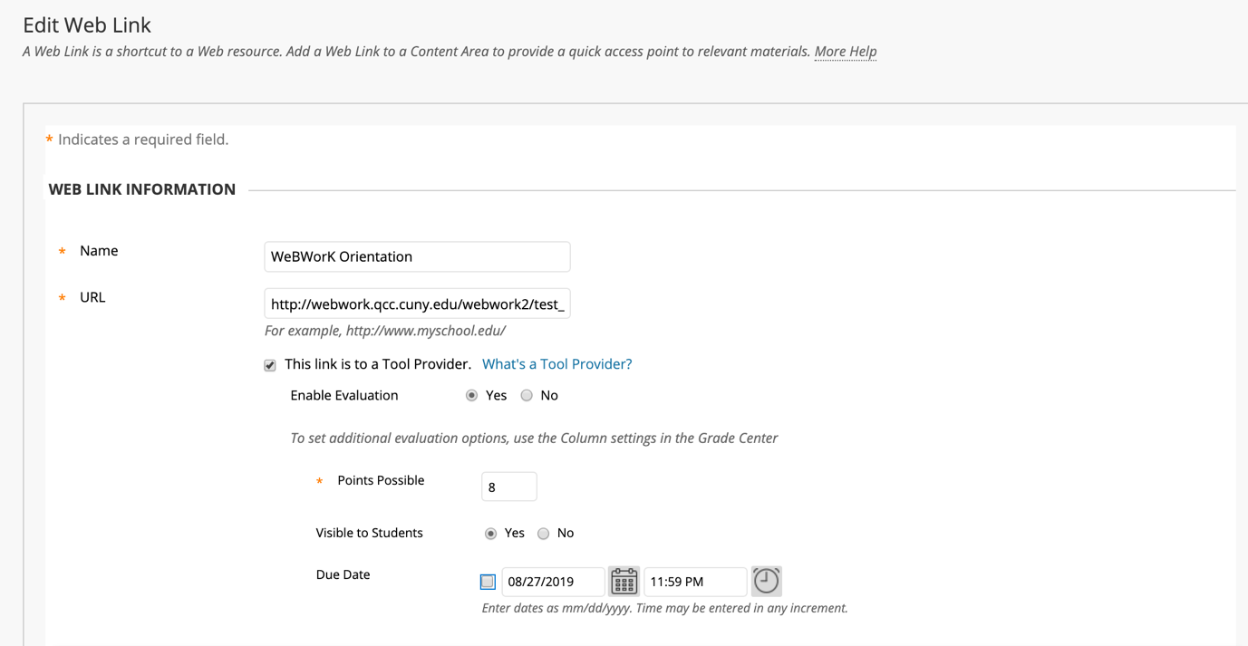

Now everything is set up and ready for the students.

The following shows the assignments links created in the content area called “WeBWorK LTI.”

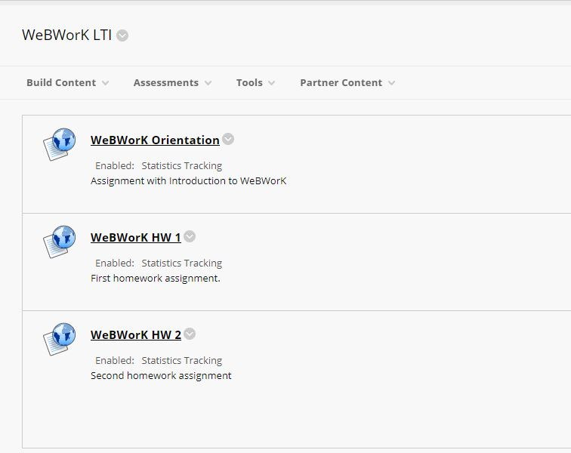

**Grade sync**

The LTI configuration in WeBWorK is set to return the total score for each assignment to Blackboard. In other words, instructors will see multiple columns in Blackboard Grade Center, one for each link/assignment, which will be filled out with the students’ scores on individual WeBWorK assignment.

WeBWorK will attempt to update student grades every time they submit an answer to a problem. This keeps the student grades current. One possible downside of this feature is that it can drain our QCC WeBWorK server.

Below is an illustration of the corresponding columns created in the Grade Center based on the assignments shown above. These columns will be filled with scores as students access the assignments using the links provides in Blackboard.

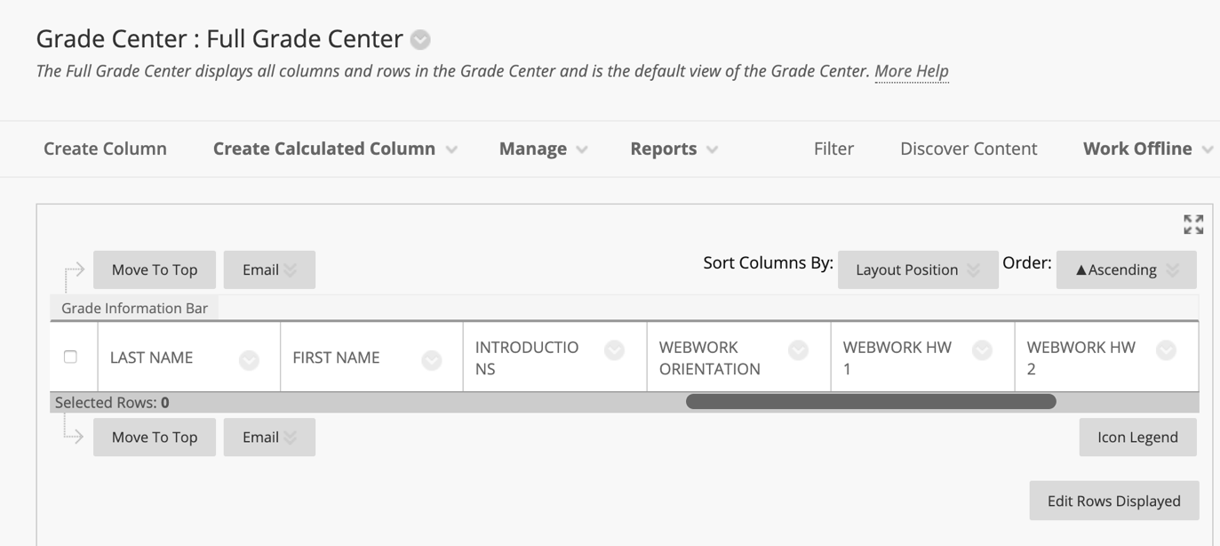

### **Testing the system as a student**

**Students’ login**

With the WeBWorK-Blackboard integration via LTI, Blackboard automatically creates students accounts in WeBWorK. A password will not be required from the students to access WeBWorK. Students are automatically assigned to all visible homework sets.

Students’ accounts created via Blackboard will not have neither a student ID nor an initial password in WeBWorK. Students will not be able to login into WeBWorK directly. There is only one way for students to login. They must log in to Blackboard and select a WeBWorK assignment.

Students see the link(s) to their WeBWorK assignment(s) in the Content area in Blackboard. They will use the link(s) to access WeBWorK assignment(s). Once students click on a link, they receive a notification that they will be redirected to an application outside Blackboard.

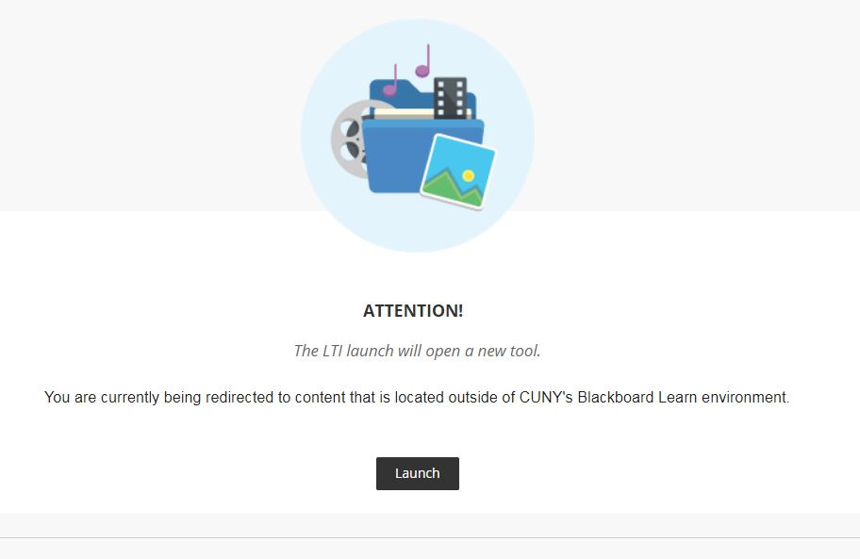

The screenshot below shows what a student see after there are logged in to WeBWorK.

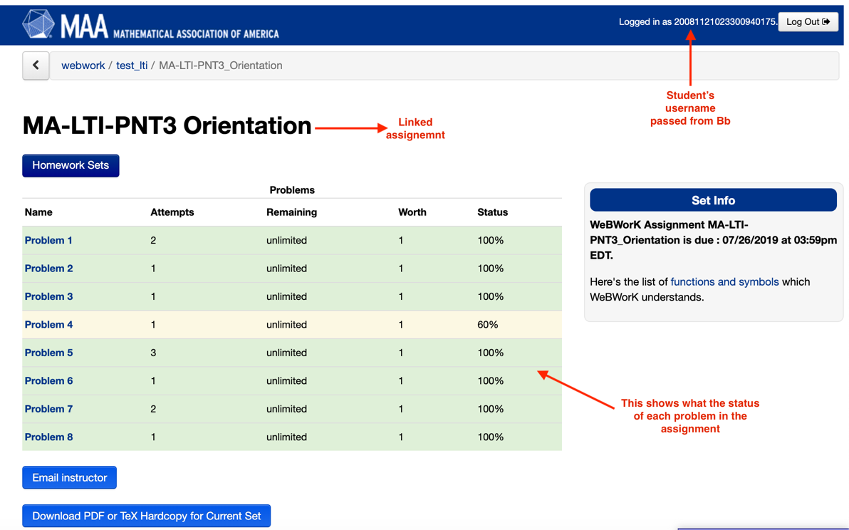

The login was successfully done via Blackboard and the student is able to submit answers to the assignment before or on the due date.

Through a customization of WeBWorK’s configuration, section and semester/year that are passed to WeBWorK as well. The information helps to facilitate instructors’ management of their course accounts in system.

Once in WeBWorK students navigate and finish assignments in exactly the same way they normally would. WeBWorK behaves just as it would if there were no connection to Blackboard at all. The only difference is when students submit a grade, they should get a message like the one below about the status of the submission.

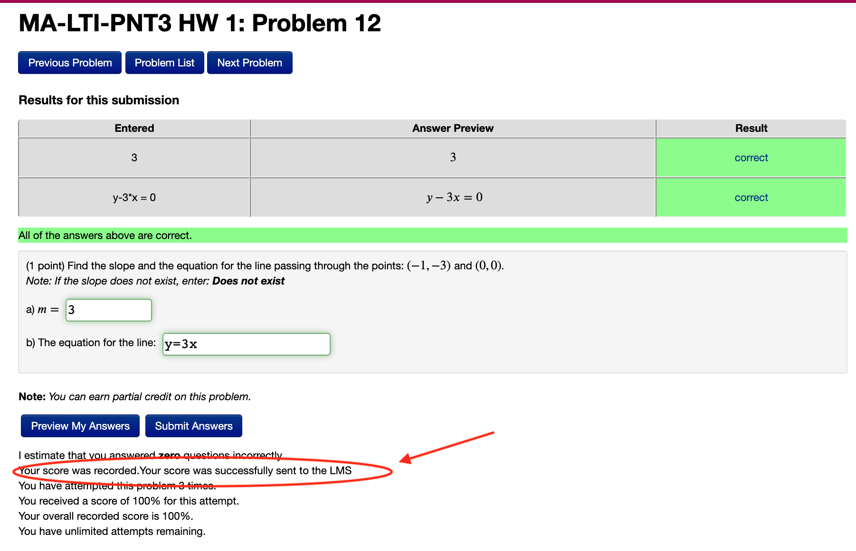

From instructors’ perspective, WeBWorK’s classlist shows the newly student account created with time stamp of the latest grade submission to the LMS, section and semester/year of the course enrollment.

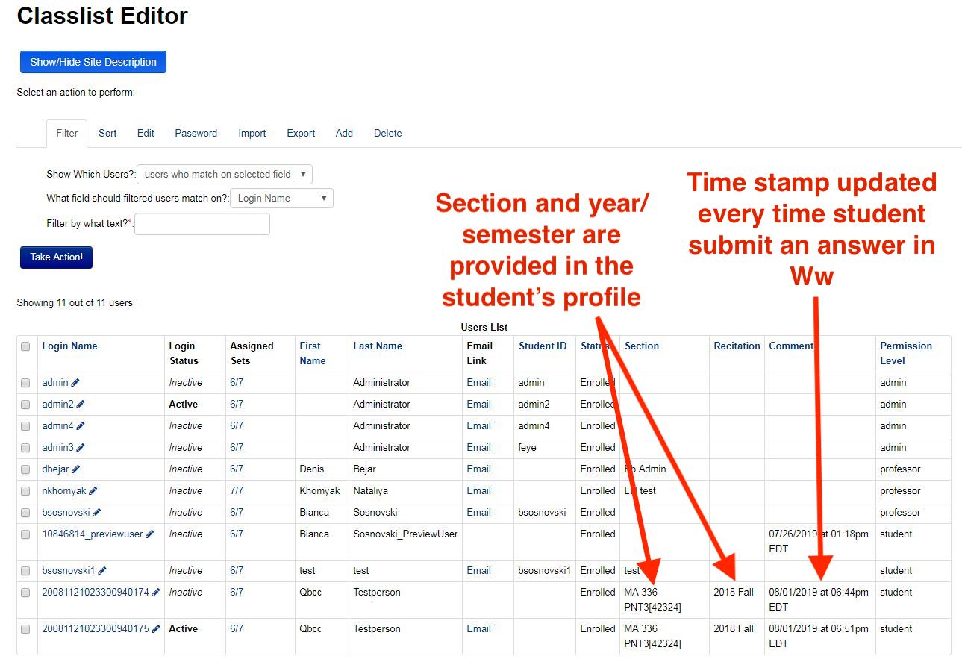

The following is the student’s view in Blackboard’s “My grades”.

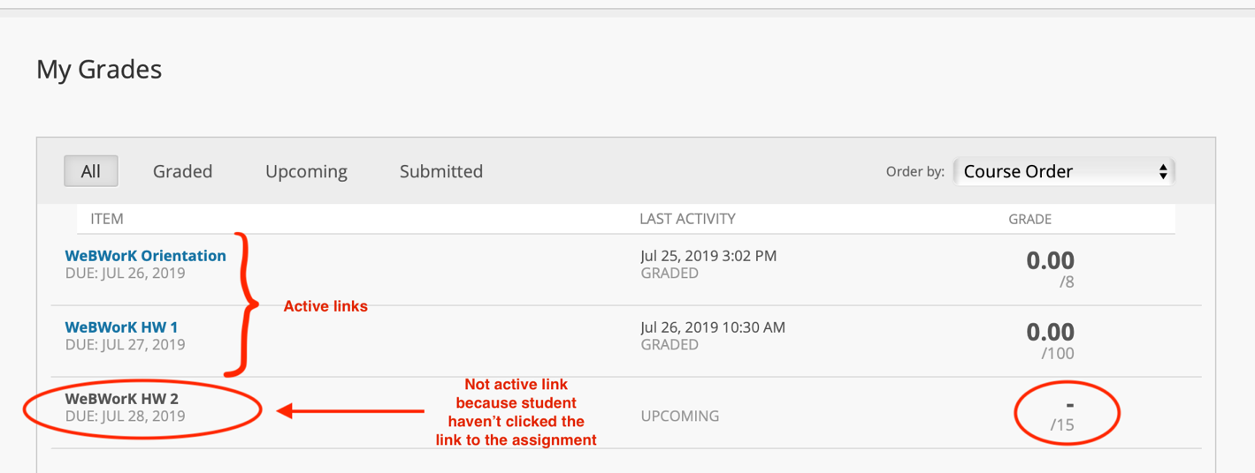

**Grade submission**

After submitting an assignment, the debugging message in WeBWorK shows that the grade was passed successfully to the LMS.

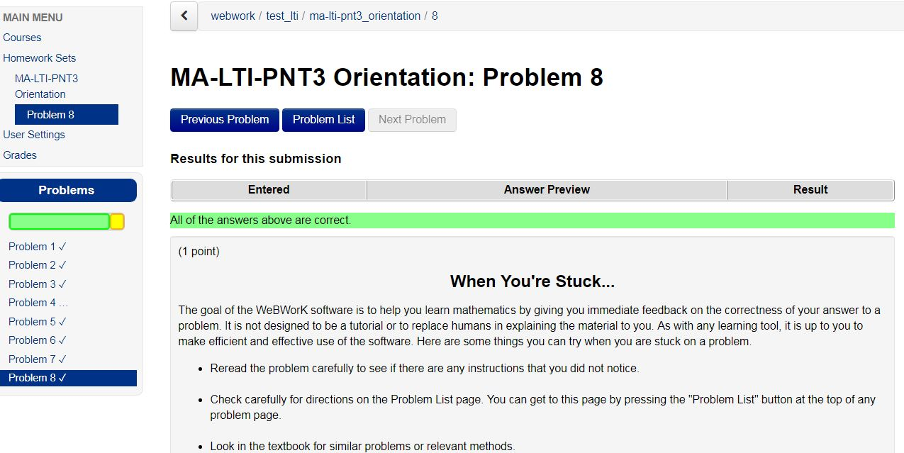

The student sees the following in WeBWork’s grades.

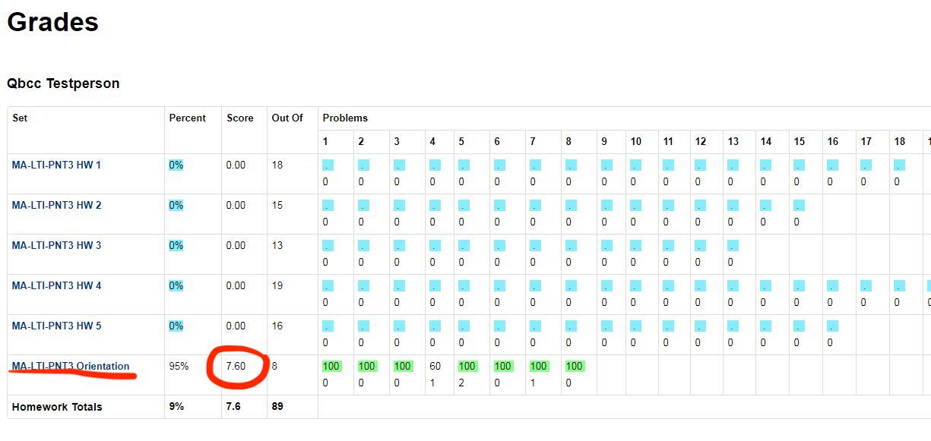

And faculty sees the following in Blackboard’s Grade Center.

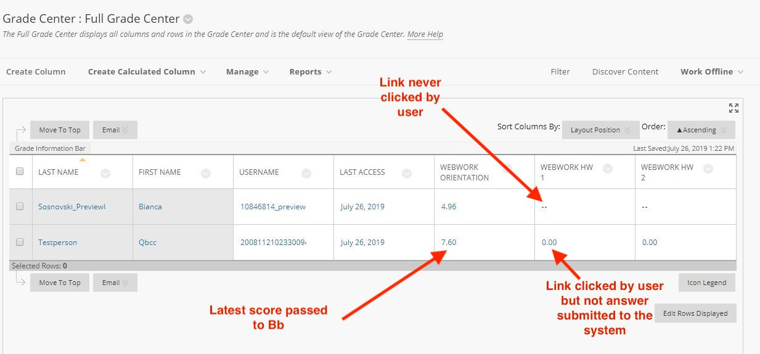

If assignments are made visible in WeBWorK but are without links in Blackboard or their links were never used by the user, students will be able to see the sets but not access them direct via WeBWorK.

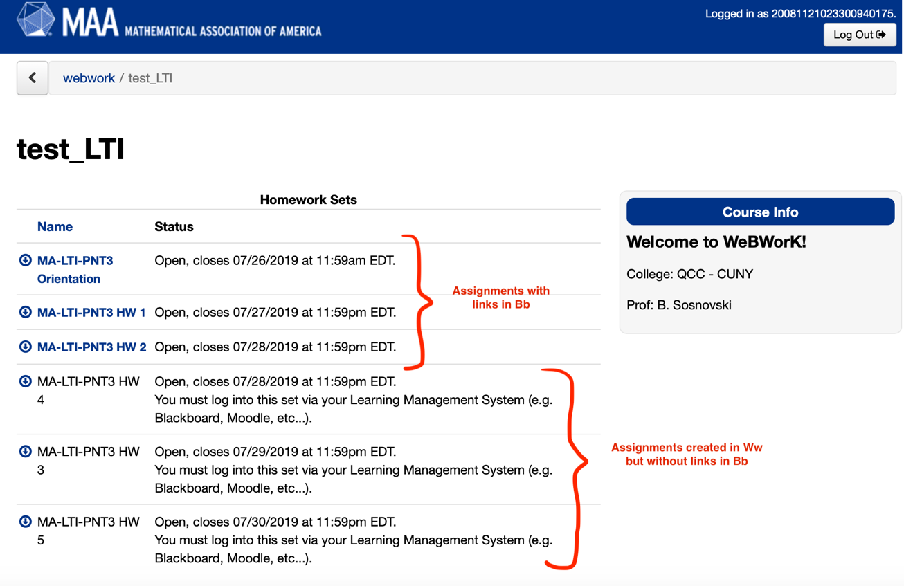

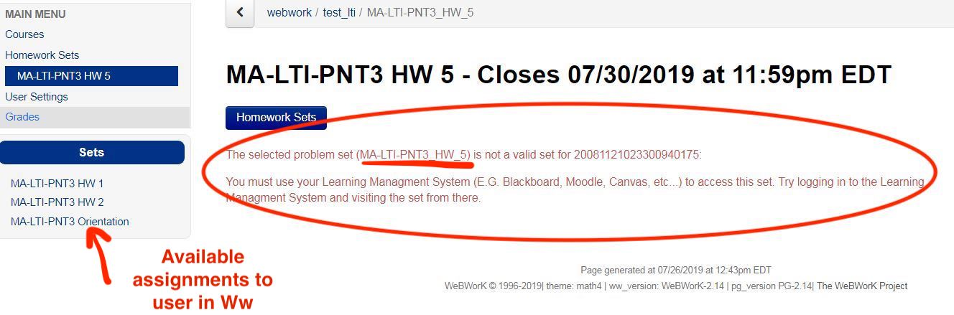

**Note:**

In Blackboard, instructors do not have grades. In this case they will see the message "Your score was not successfully sent to the LMS". This is OK. The following shows what they see in WeBWorK.

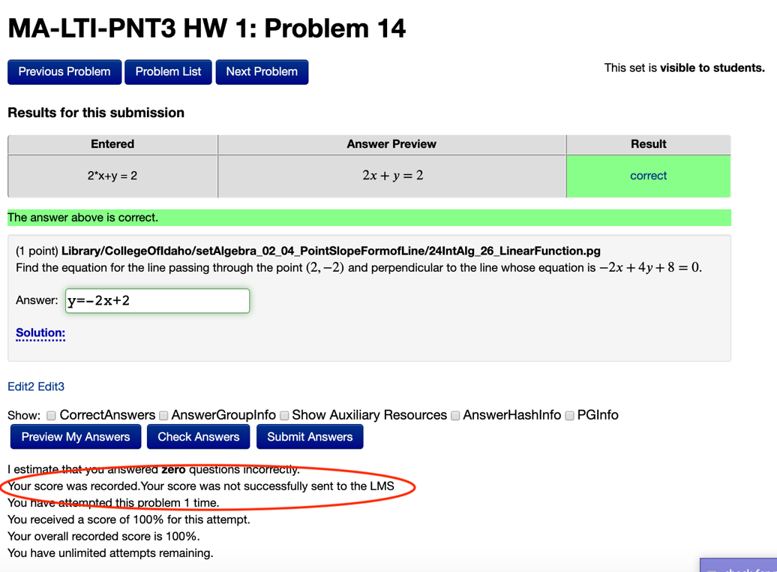

Instructors can switch to the “Student Preview” mode and click on the assignment link. Once the Instructors successfully logged in and see the assignment and try answering some questions, they will see the corresponding scores appear in your student preview account in Blackboard's Grade Center. If any of these steps are unsuccessful, they need to troubleshoot.

Student preview mode ensures grades are passed back to Blackboard; otherwise, grades are not be passed back. In either case, Blackboard logs you into the same account in WeBWorK.

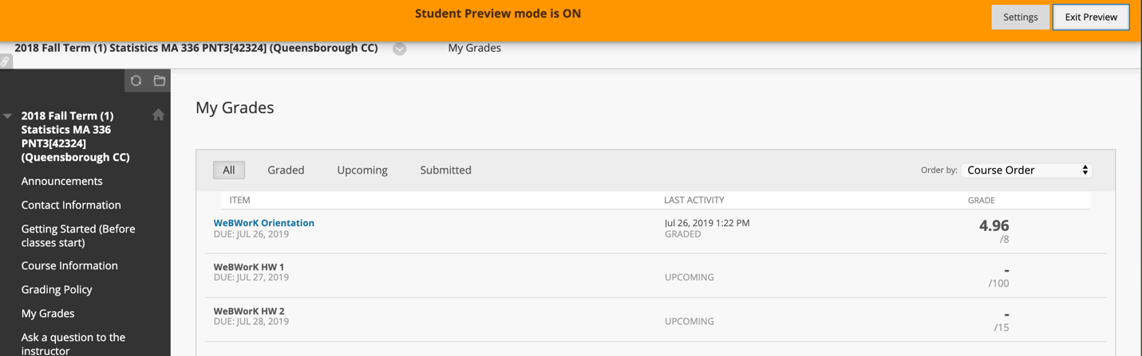

### **Other WeBWorK’s features:**



One of the important features in WeBWorK is the button, which students use to communicate with instructors about a specific problem in the assignment posted.

If a student clicks on the button, she/he will be taken to a page where they can type a question that will be sent to your instructor. Then the instructor will receive a link that will take her/him directly to the problem student is working on.

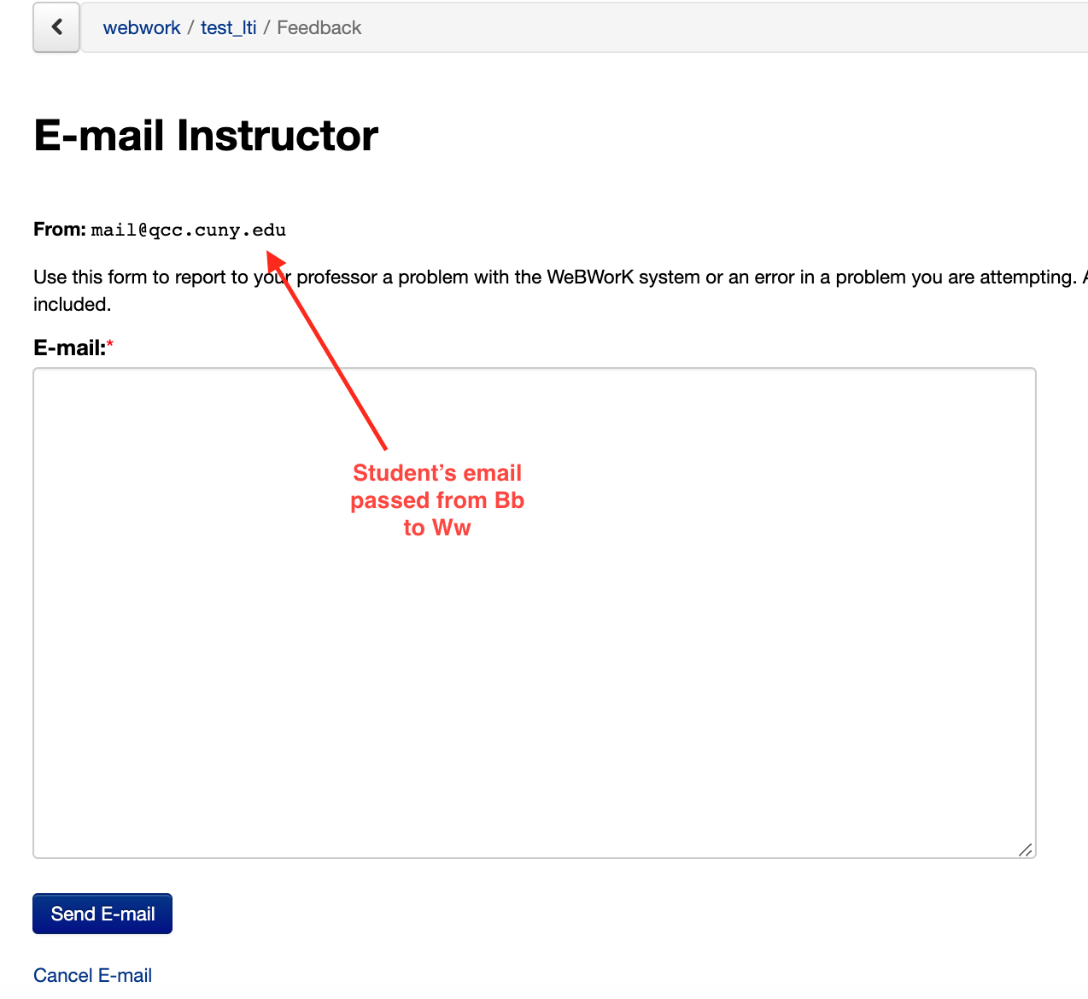

This WeBWorK’s feature helps faculty to provide feedbacks to students.

### **Summary**

With the integration, the Department's WeBWorK server allows direct login via Blackboard and it includes:

* Automatic creation of WeBWorK student accounts from Blackboard (**successful**);
* Single login via Blackboard (**successful**);
* Automatic grade passback from WeBWorK to Blackboard (**successful**);
* Assignments are assigned to users once visible (**successful**).

What remains the same:

* WeBWorK courses are created at the request of course instructors by the department WeBWorK administrators;
* Instructor accounts must be manually created on WeBWorK;
* Assignments are created, opened and closed on WeBWorK.